CALIFORNIA MENTAL HEALTH SERVICES AUTHORITY
“CalMHSA”
PARTICIPATION AGREEMENT AMENDMENT NO. 3
SEMI-STATEWIDE ENTERPRISE HEALTH RECORD PROGRAM

This Participation Agreement Amendment No. 3 (“Amendment No. 3”) amends Participation Agreement
No. 1575-EHR-2022-NC, executed on July 20, 2022, (the “Agreement”) and is entered into by and between the California Mental Health Services Authority (“CalMHSA”) and Nevada County (“Participant”). This Amendment No. 3 shall be effective as of November 1, 2024.

CalMHSA and Participant agree to amend the Agreement to incorporate additional purchases and to establish an approved “Maximum Funding” amount, not to be exceeded, with the intention of promoting the necessary flexibility and agility to meet Participant’s programmatic needs in a timely manner.

CalMHSA and Participant agree that the total approved maximum programmatic funding (“Maximum Funding”) allocated by Participant in the Agreement to the Semi-Statewide Enterprise Health Record Program (“EHR”) shall not exceed the amount of $2,281,864.27.

The Maximum Funding stated above includes the funding Participant has committed to EHR program-related components, modules and implementations purchased to date (“Participant-Specific Committed Funding”) in the amount of $2,267,035.34.

CalMHSA and Participant agree to amend the Agreement by adding or revising the following term(s):
Additional Purchases:
This Amendment No. 3 incorporates additional component purchases totaling $252,612.29 in additional committed funding.
The additional component purchases include:
- Purchase of a subscription to use the “SmartCare CalMHSA Package” for 73 additional EHR Users. This item is an annual application subscription, which will be invoiced on a monthly basis.
- Purchase of a subscription to use the “Disaster Recovery” for 73 additional EHR Users. This item is an annual application subscription, which will be invoiced on a monthly basis.
  - Excess User Subscription Fees. CalMHSA will regularly audit Participant’s EHR User count to ensure compliance with the terms of the Agreement. If, in any given month, Participant’s number of users exceeds the amount specified in Exhibit C, Participant agrees to pay the per-user license fees for each additional user as outlined in the table immediately below. Participant agrees to pay these additional fees within thirty (30) days following receipt of an invoice from CalMHSA.

Per User Per Month Subscription Fees | 3/1/24 - 2/28/25 | 3/1/25 - 2/28/26 | 3/1/26 - 2/28/27 | 3/1/27 - 2/28/28 | 3/1/28 - 3/18/29
SmartCare CalMHSA Package | $58.46 | $60.21 | $62.02 | $63.88 | $65.80
Disaster Recovery - Subscription | $3.66 | $3.77 | $3.88 | $4.00 | $4.12
Total | $62.12 | $63.98 | $65.90 | $67.88 | $69.92

Revised Exhibit B, Section V. Fiscal Provisions:

While adhering to, and under no circumstances exceeding, the approved Maximum Funding amount of $2,281,864.27, Participant’s Behavioral Health Department is explicitly authorized to utilize unallocated Program funds within the approved Maximum Funding amount for the purchase of additional components, modules, implementations, users, etc., related to the EHR program. Any such purchase shall require the execution of an Order Form (attached as Exhibit E hereto) signed by Participant’s Behavioral Health Director.

Notwithstanding the above, any change in the Maximum Funding amount shall require approval of the Participant’s Board of Supervisors.

Revised Exhibit C – Participant Specific Committed Funding and Terms:

The table below reflects the additional purchases affected by the Amendment No. 3, listed above, and the associated increase of $252,612.29 in Committed Funding.

This revised Exhibit C replaces Exhibit C in the Agreement, effective November 1, 2024. The revised amount of Participant-Specific Committed Funding for the program term is $2,267,035.34, as stated below:

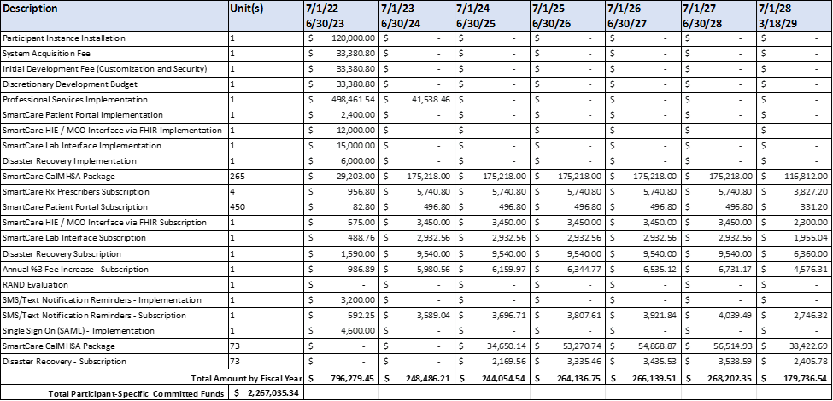

Additional purchase description

Description | Fee Type Description | Payment Term
SmartCare CalMHSA Package Subscription | The “SmartCare CalMHSA Package” is the primary subscription which includes:  - Use of the EHR  - Cloud Hosting of the Software/System (99.95% Up-Time)  - CalMHSA Support of the System (Tier 1)  - Contractor Support and Maintenance of the System (Tier 2). | The annual subscription amount shall be invoiced on a monthly basis. Monthly payments shall be due upon receipt of invoice.
Disaster Recovery Subscription | Disaster recovery subscription provides the infrastructure and as-needed services to assure Participant's ability to access to the Enterprise Health Record (EHR) after events like a natural disaster, cyber attack, etc. Disaster recovery relies upon the replication of data and computer processing in an off-premises location not affected by the disaster. With this subscription, should such an event occur, access to the EHR will be re-established within 4 hours with data loss not to exceed 15 minutes.

Revised Exhibit D – Participant Contingency Budget:

Amendment No. 3 revises the Agreement to remove Exhibit D – Participant Contingency Budget and all references to Exhibit D, Contingency Funds or Contingency Budget throughout the Agreement. Within the approved Maximum Funding, unallocated funds may be utilized by Participant’s Behavioral Health Department for the purchase of additional components, modules and/or implementations related to the EHR program.

All other terms or provisions in the Agreement and subsequent Amendments, not cited in this Amendment No. 3, shall remain in full force and effect.

CalMHSA
Signed: | Name (Printed): Dr. Amie Miller, Psy.D., MFT
Title: Executive Director | Date:
Participant:
Signed: | Name (Printed):
Title: | Date:

EXHIBIT E

CALIFORNIA MENTAL HEALTH SERVICES AUTHORITY
“CalMHSA”
ORDER FORM NO. __
SEMI-STATEWIDE ENTERPRISE HEALTH RECORD

This Order Form No. __ is a contract by and between the California Mental Health Services Authority (“CalMHSA”) and _______ County (“Participant”).
CalMHSA and Participant entered into Participation Agreement No. __________ executed on __________ (the “Participation Agreement”).
Participant intends to purchase additional components, modules and/or services as specified below. CalMHSA and Participant agree to incorporate the additional purchases and corresponding Committed Funding modifications as follows:
ADDITIONAL PURCHASES:
This Order Form No. __ incorporates additional component purchases totaling __________ in additional Committed Funding. Pricing and payment terms for each additional component purchased can be found in Exhibit E-1, below.
The additional component purchases include:
- Purchase of a subscription to use the [component, module or service purchased]. This item is an annual application subscription, which will be invoiced on a monthly basis.
- Purchase of professional services to implement the [component, module or service purchased]. This fee is a one-time charge to be invoiced upon execution of this Order Form No. __.
This Order Form No. __ adds $__________ in additional Committed Funding. The revised total maximum amount of Committed Funding shall not exceed $__________ inclusive of the __________ increase, for the program term as specified in the Participation Agreement.

EXHIBIT E-1 – ADDITIONAL COMPONENT PURCHASE DESCRIPTION AND PAYMENT TERMS
The table below describes the additional component purchases incorporated by this Order Form No. __, effective as of the date of execution of this Order Form No. __. The components listed are in addition to those included in the Participation Agreement and all subsequent Amendments and Order Forms, if any, that preceded this Order Form No. __.

Description | Fee Type Description | Payment Term
[Component, module or service] Implementation. | One-Time Fee associated with the implementation efforts to support [component, module or service purchased]. | The fee for this implementation service shall be due upon execution of this Order Form No. __.
[Component, module or service] Subscription. | [Component, module or service subscription description]. | The annual subscription amount shall be invoiced on a monthly basis. Monthly payments shall be due upon receipt of invoice.

All other terms or provisions in the Participation Agreement and all subsequent Amendments and Order Forms, if any, that preceded this Order Form No. __, not cited herein, shall remain in full force and effect.

CalMHSA
Signed: | Name (Printed): Dr. Amie Miller, Psy.D., MFT
Title: Executive Director | Date:
Participant:
Signed: | Name (Printed):
Title: | Date:

