AMENDMENT NO. 1 TO PROFESSIONAL SERVICES CONTRACT RES 23-426
With Polco

THIS AMENDMENT is executed this 14th day of January 2025 by and between Polco and County. Said Amendment will amend the prior contract between the Parties entitled Conduct one National Citizen Survey and one National Employee Survey approved on August 8, 2023 by Resolution No. 23-426.

WHEREAS, the Parties desire to amend the Contract to allow for an in-person presentation of results and remote presentation of results; and

WHEREAS, the Parties desire to amend the Contract to update the timeline for the National Employee Survey to be conducted in Fall/Winter 2025; and

WHEREAS, the Parties desire to amend the Contract to extend the contract period from June 30, 2025 through June 30, 2026 to accommodate the updated timeline for the National Employee Survey.

NOW, THEREFORE, the Parties hereto agree as follows:

- That the Schedule of Services, Exhibit "A" shall be amended to reflect the updated timeline for the National Employee Survey:
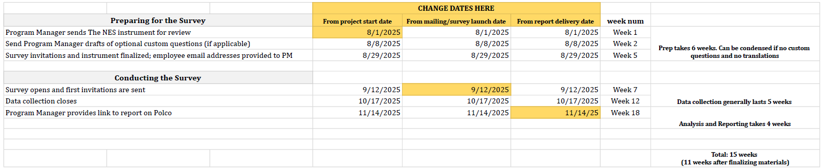

- That paragraph three shall be repealed and replaced as follows: Term This Contract shall commence on July 1, 2023. All services required to be provided by this Contract shall be completed and ready for acceptance no later than the Contract Termination Date of: June 30, 2026.

3. That the Schedule of Charges and Payments, Exhibit "B" shall be amended by adding the following and increasing the total amount of the Contract by $6,200 for a not to exceed amount of $46,055:

In Person Presentation of Results
A senior Polco staff member will make one presentation of survey results to staff, Council, Boards, or other appropriate groups. For this presentation, we use Microsoft® PowerPoint or Google Slides as a visual aid and a copy of the slideshow is left with your staff for internal use. $4,600.00

Remote Presentation of Results
A senior Polco staff member will make one presentation of survey results to staff, Council, Boards, or other appropriate groups. This will be conducted on Zoom or another appropriate technology (that is feasible for both parties and suits the purpose). For this presentation, we use Microsoft® PowerPoint or Google Slides as a visual aid and a copy of the slideshow is shared with your staff for internal use. $1,600.00

4. That in all other respects the prior agreement of the parties shall remain in full force and effect except as amended herein.

APPROVED AS TO FORM: COUNTY OF NEVADA
COUNTY COUNSEL

By:________________________ By:_____________________________

Chair, of the Board of Supervisors

ATTEST: CONTRACTOR:

By:____________________________ By:________________________
Jeffrey Thorsby
Clerk of the Board of Supervisors

